**HIRING PROCESS ANALYTICS**

**Project Description:** The overview of the project is to analyze the given data of previous hiring and to draw insights from it, and providing trends from that data and helping to the hr department or hiring department.

**Tech-Stack Used:** Here I am using MS Office Proffesional Plus 2019.



**Approach:**

**Cleaning Data:**

1.Here a 1 record with the null value has been deleted.

2.I have deleted 16 records of ‘–‘ valued rows. As the total data is of nearly 7167 data so without these 16 records it will be 7151 records. So as far as I considered this wouldnot effect the value so I have deleted them instead of using random values.

3.Here I have changed the department value from c-10 to c10 for conviniece.

Later For every case I have created different sheet for the purpose of showing it rather than doing all the stuff in one sheet.

**Here is the Hyperlink file:**

[**https://docs.google.com/spreadsheets/d/1mn4k7lOssrbiyncC1UwKCeKEw5-8nSOE/edit?usp=sharing&ouid=109306873346171611691&rtpof=true&sd=true**](https://docs.google.com/spreadsheets/d/1mn4k7lOssrbiyncC1UwKCeKEw5-8nSOE/edit?usp=sharing&ouid=109306873346171611691&rtpof=true&sd=true)

Please find the attached document for all the questions or cases provided.

A.Hiring Analysis: The hiring process involves bringing new individuals into the organization for various roles.

|  |  |
| --- | --- |
| Male candidates hired | 2562 |
| Female candidates hired | 1856 |
| Don't want to say | 268 |
| **Total** | **4686** |

Here I have just considered the hired employee and wrote the formula :

Ex: =COUNTIFS('Modified Data'!D2:D7152,"Male",'Modified Data'!C2:C7152,"Hired")

B. Salary Analysis: The average salary is calculated by adding up the salaries of a group of employees and then dividing the total by the number of employees.

For this case I have used two formulae for the average salary of hired employee only.

Ans: 49735.41293

Ex: =SUMIF('Modified Data'!C2:C7152,'Modified Data'!C7141,'Modified Data'!G2:G7152)/COUNTIFS('Modified Data'!A2:C7152,'Modified Data'!C7141)

C. Salary Distribution: Class intervals represent ranges of values, in this case, salary ranges. The class interval is the difference between the upper and lower limits of a class.

For this case I have did like below to name the ranges.

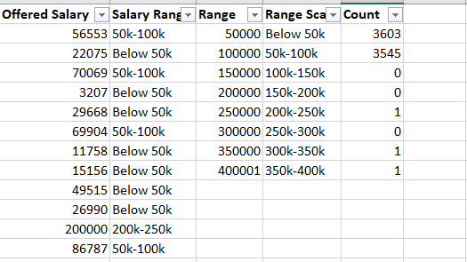

You can find it in drive link for more info.

I just drawn a chart to show the number of count or how many employee are more in which price ranges.

D. Departmental Analysis: Visualizing data through charts and plots is a crucial part of data analysis.

For this case I have used piechart to make sure that every department shows the percentage of employee to overall count.

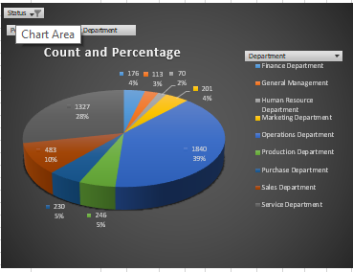

Here I have considered only hired people.

E. Position Tier Analysis: Different positions within a company often have different tiers or levels.

For this case I am not sure of what exactly needed to I have drawn 3insights for this.

Please go through the link for more info.

Here I am attaching the pics of the **E. Position Tier Analysis because these are not showing properly in link. Kindly find them.**

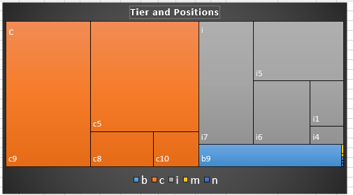

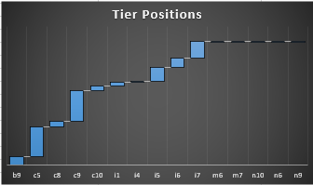

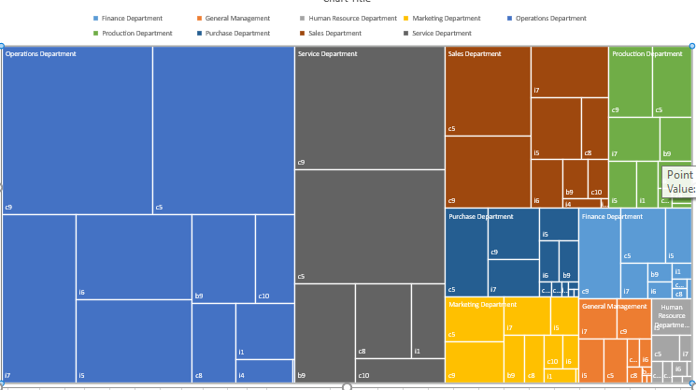

**Insights:** While working this project I have learnt new things and new formulae of excel. It is a bit simple I can say except the last case. Here the data will provide like howmany rejections are done and which gender hired more. In this case it is Male candidates. The average of salaries can be show the insight like which is the average salary that we can afford to an employee. For the Department analysis we can say that Operations department need more man power than any other department. So please recruit more employee for that department.

**Results:** It is very much helpful to me to increase my knowledge in data analytics and this my first time of using charts in excel, I have worked on them in Power Bi earlier. Through this I have gained more knowledge on excel formulas and analyzing data and cleaning of data.

Thanks for the knowledge you are provided.